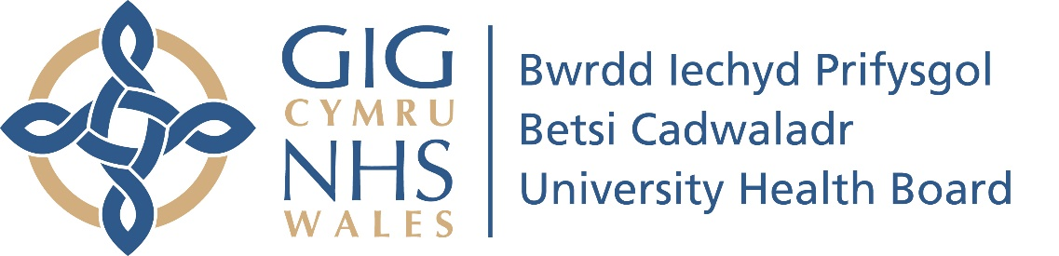

COVID-19 Vaccination Update 15.06.21

From Gill Harris – Executive Director of Nursing and Midwifery

We’re continuing to make good progress, with 85 per cent of eligible adults vaccinated with a first dose, and 55 per cent receiving both doses. This includes at least 80 per cent take up among all groups above the age of 40.
We are currently targeting those aged 30-39 (currently 59 per cent take up) and those aged 18-29 (currently 68 per cent take up) and are continuing to use a variety of communications to encourage our younger citizens to take up the offer of the vaccine.
We’ve come so far, so quickly, but the speed at which we can all return to normal life could depend on how swiftly we vaccinate the remainder of people in these younger age groups.

Delta variant
This has become especially important in light of the emergence and continued spread of the delta variant of coronavirus, which is thought to be 60 per cent more transmissible than the previously dominant alpha variant.
The delta variant is spreading much more quickly amongst people who have not been vaccinated and now accounts for over 90 per cent of new positive coronavirus cases in North Wales.
A study published in The Lancet revealed that those infected with it are 85 per cent more likely to be admitted to hospital than those with the alpha variant.
Getting the full protection of both doses of the COVID vaccine is the best way to protect yourself and your loved ones. The risk of hospitalisation from the delta variant falls by around 70 per cent, 28 days after having a second dose.
Those in younger age groups who feel no personal risk from COVID are reminded that vaccination is the best way to ensure that restrictions are eased and we can all return to normal life. Proof of vaccination may be required to travel on holiday abroad and attend festivals, concerts and sporting events.

Booking your appointments is now easier than ever
It’s quick and easy to book a first or second dose of the COVID vaccine at a convenient date, time and location using our online booking service. There are clinics available in locations across North Wales and new appointments are being added on a regular basis.
We will also continue to hold short notice vaccination drop in sessions, in order to increase flexibility and ensure that we continue to avoid any vaccine wastage
If you’ve not yet had your first dose please don’t wait for an appointment letter to arrive in the post – book your appointment online as soon as possible.
Owing to the threat posed by the delta variant, we’ve brought forward the second dose interval for the Pfizer vaccine to eight weeks.
This means that anyone who has had a first dose of the Pfizer or AstraZeneca vaccine can now book their second dose appointment for the same brand vaccine, once eight weeks have passed since their first dose.

Advice for those unable to access the internet
If you cannot access the internet to book online, please phone our COVID-19 Vaccination Contact Centre on 03000 840004. The lines can be very busy, so please be patient.

Worried about having the vaccine?
If you have any concerns about receiving the vaccine, please book and attend your appointment, so we can take the time to discuss them with you, before you decide whether to go ahead.
It’s important that you make an informed decision about whether to be vaccinated, based on the latest information from trusted sources. The Public Health Wales website is a great place to start.

Advice for those living in North Wales but registered with a GP in England
Those living in North Wales who are registered with a GP in England can receive their COVID vaccine at any of the clinics bookable through our website. Our online booking service has been updated to reflect this.
This is especially relevant to people living in border towns and villages in Flintshire and Wrexham.

