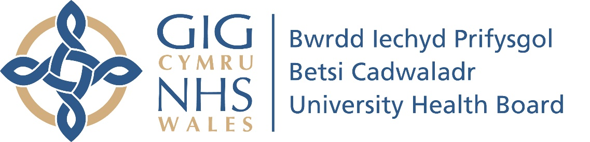

COVID-19 Vaccination Update 27.10.21

From Gill Harris – Executive Director of Nursing and Midwifery
Our teams are working flat out to get booster jabs into the arms of people in the top priority groups as quickly as possible.
We’re administering around 3,000 vaccines every day, and we are on track to have offered the booster jab to 90 per cent of those eligible by mid-December - an aim that is shared across Health Boards in Wales.
In this week’s briefing we have included answers to frequently asked questions received over the past week.
You can find answers to other Frequently Asked Questions on our website here.
When will I be invited for my COVID-19 booster?
Please remember, six months is the minimum interval between your second dose and getting your booster.
We’re currently administering boosters to frontline health and social care staff and those aged over 80. We have begun sending appointment letters to those aged over 70.
Provided six months have passed since a second dose jab, we are inviting people eligible for their booster in the same priority order as the first phase.
We are on track to have offered the jab to 90 per cent of those eligible by mid-December.
Please wait for an appointment invitation in the post and don’t contact your GP surgery or our COVID-19 Vaccination Contact Centre, as they will not be able to book one for you any sooner.
Once you receive an appointment, please make every effort to keep to it.
Why do I have to travel further for my booster jab?
During the first phase of the vaccination programme, nearly all GP Practices were vaccinating using the AstraZeneca vaccine. This ensured that a significant number of people could receive their first and second dose at a local GP surgery.
The Pfizer vaccine is being used for the booster programme, which has a short usage window and very specific transportation, storage and preparation requirements. This has made it difficult for many GP Practices to take part in the booster programme.
GP Practices are also dealing with unprecedented demand for care and are extremely busy with the important work of administering flu vaccines.
Because we are now administering vaccines from fewer sites, some people may be asked to travel further for their booster vaccine than they did to receive their first or second jab.
All of our COVID-19 vaccination sites are on public transport routes. Those with concerns about how they can travel to their appointment are invited to contact us.

Difficulties getting through to the COVID-19 Vaccination Contact Centre
Our COVID-19 Vaccination Contact Centre is continuing to experience very high call volumes. The average waiting time for a call to be answered this month is 6 minutes and 44 seconds, which is longer than we would like. We are continually trying to recruit additional staff.
Please help us help you by making every effort to stick to your booster appointment and only call us to reschedule if this is unavoidable.

First dose appointments for those aged 12-15
We’re still sending appointment invitations to this group, so if your child hasn’t received a letter just yet, please don’t worry that they have been missed. There’s no need to call us to try and book an appointment.
This week we’re holding the following half term walk-in clinics for anyone aged 12-17 years and 9 months only to receive their first dose, if they don’t already have an appointment booked in the coming weeks:

Wrexham
Catrin Finch Centre – Sunday 31st October from 09:00 to 17:00
Queensferry
Deeside Leisure Centre – Sunday 31st October from 09:00 to 19:00
St Asaph
Optic Centre – Saturday 30th and Sunday 31st from 08:30 to 19:30

Llandudno
Sector House – Saturday 30th and Sunday 31st from 08:30 to 19:30
Llangefni
Plas Arthur Leisure Centre - Thursday 28th October from 10am-5.20pm
Bangor
Ffriddoedd Road - Thursday 28th October from 9am – 6:30pm.

Please keep to your existing appointment, if you have one booked in over the coming weeks.
Please note that a parent or guardian of those aged 12-15 will need to accompany them when receiving their vaccination.

Getting a flu and booster jab provides the best protection
Please take up the offer of the flu and booster jabs as soon as they are offered. There is no need to leave a gap between each jab. The Joint Committee on Vaccination and Immunisation (JCVI) has advised that it is safe for flu and booster vaccines to be administered at the same time or at any time after - no spacing is required

Most people won’t be offered their flu and COVID-19 booster vaccines at the same time. Your booster vaccine will in most cases be given at a COVID-19 Vaccination Centre, while your flu vaccine will in most cases be given at your GP surgery. Most people will receive separate appointment letters for both jabs.

First and second doses
Public Health Wales data released last week shows that the hospital admission rate for younger, unvaccinated adults with COVID-19 in Wales is more than four times higher than for those who have been fully vaccinated.
It’s not too late to come forward for a first dose of the COVID-19 vaccine. It’s also vitally important that those who have had their first dose receive their second, eight weeks later, in order to receive the very best protection.
First or second doses can only be booked through our COVID-19 Vaccination Contact Centre telephone number: 03000 840004. The lines are open Monday to Friday, 8am to 7pm and Saturday to Sunday, 9am to 2pm.
To help manage demand, we are no longer offering walk-in clinics, or online booking for first or second doses (except for the half term walk in clinics detailed above).

Help us keep North Wales safe this winter
Rates of COVID-19 are still at worryingly high levels and the NHS in Wales is entering its most challenging period of the pandemic. Please help keep North Wales safe and protect the NHS this winter by:
- Taking up the offer of the Flu and Booster jabs as soon as they are offered. For more information please visit our website

- Continuing to follow the public health advice around ‘hands, face, space and fresh air’

- If you need NHS care, please choose the most appropriate service for your needs by visiting the NHS 111 website or the BCUHB website

